1. Create a new GitHub repository.
- Clone the repository to your local machine using SSH (generate an SSH key if needed, add the public key to your GitHub account).
- Create a new branch named after your username (e.g., Tutedude).
- Add your Flask project files to this branch.
Commit the changes and merge the branch into the main branch.
# 1. Create a new repo on GitHub (choose SSH as the clone option)
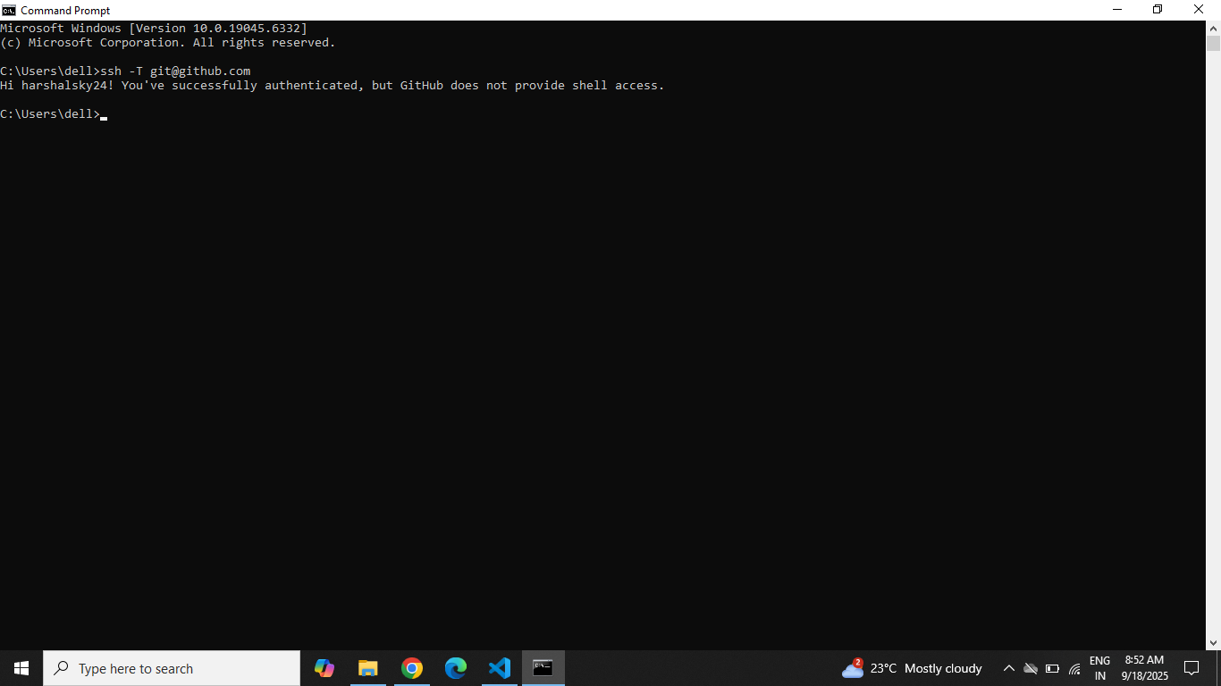

# 2. Clone via SSH
git clone git@github.com:harshalsky24 /tutedude .git
cd tutedude
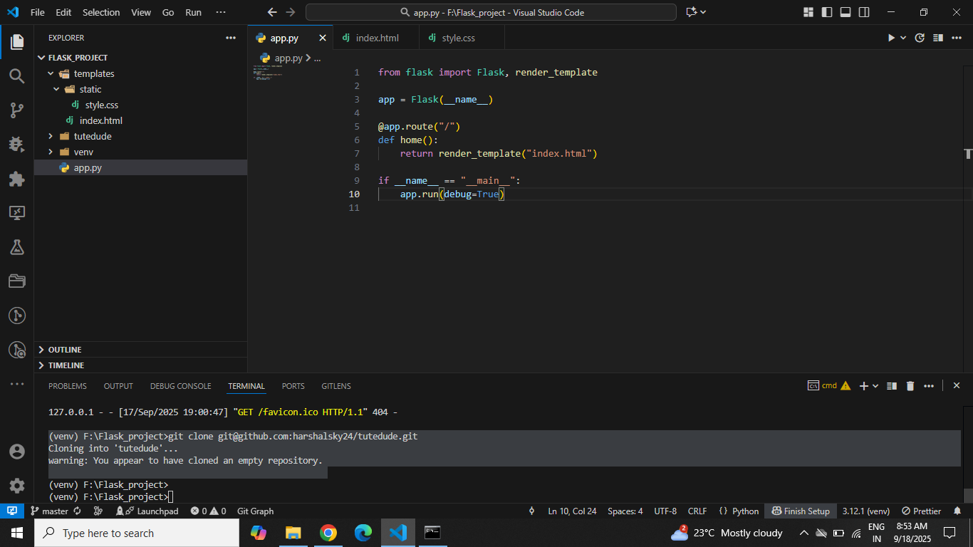

# 3. Create new branch (e.g., harshalsky24)
git checkout -b harshalsky24

# 4. Copy/Place your Flask project files here (app.py, templates, static, data.json)
git add .
git commit -m "Initial Flask project commit"
git push origin harshalsky24
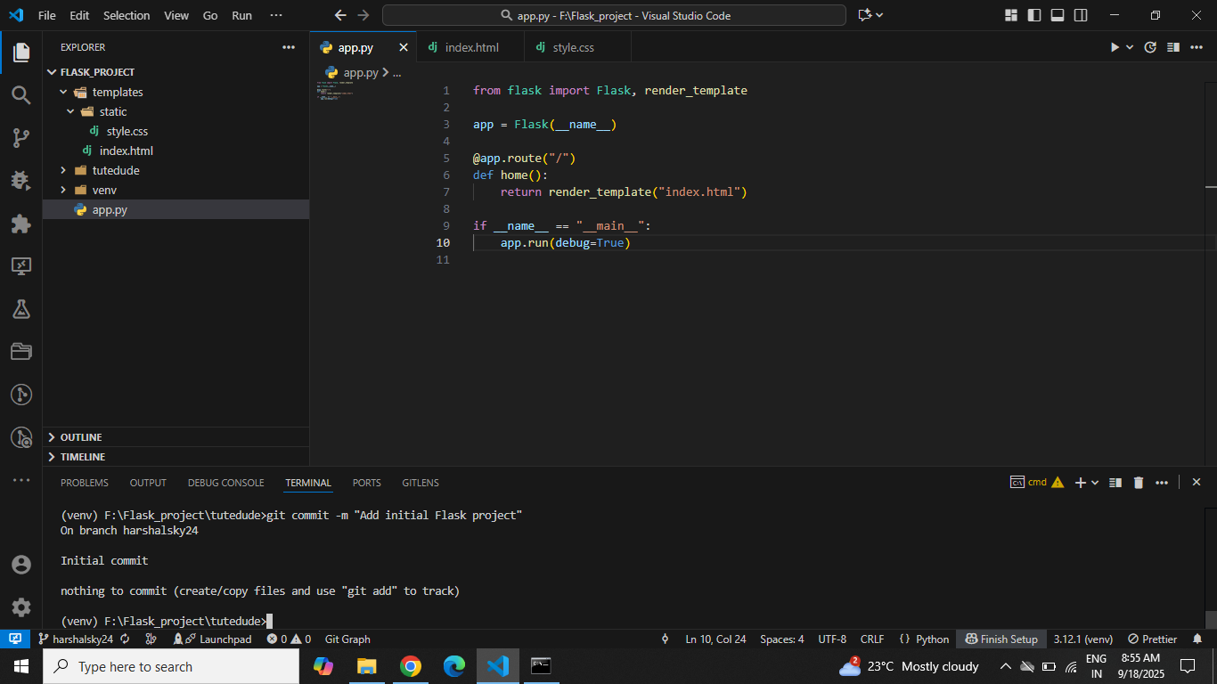

# 5. Merge to main
git checkout main
git merge harshalsky24
git push origin main

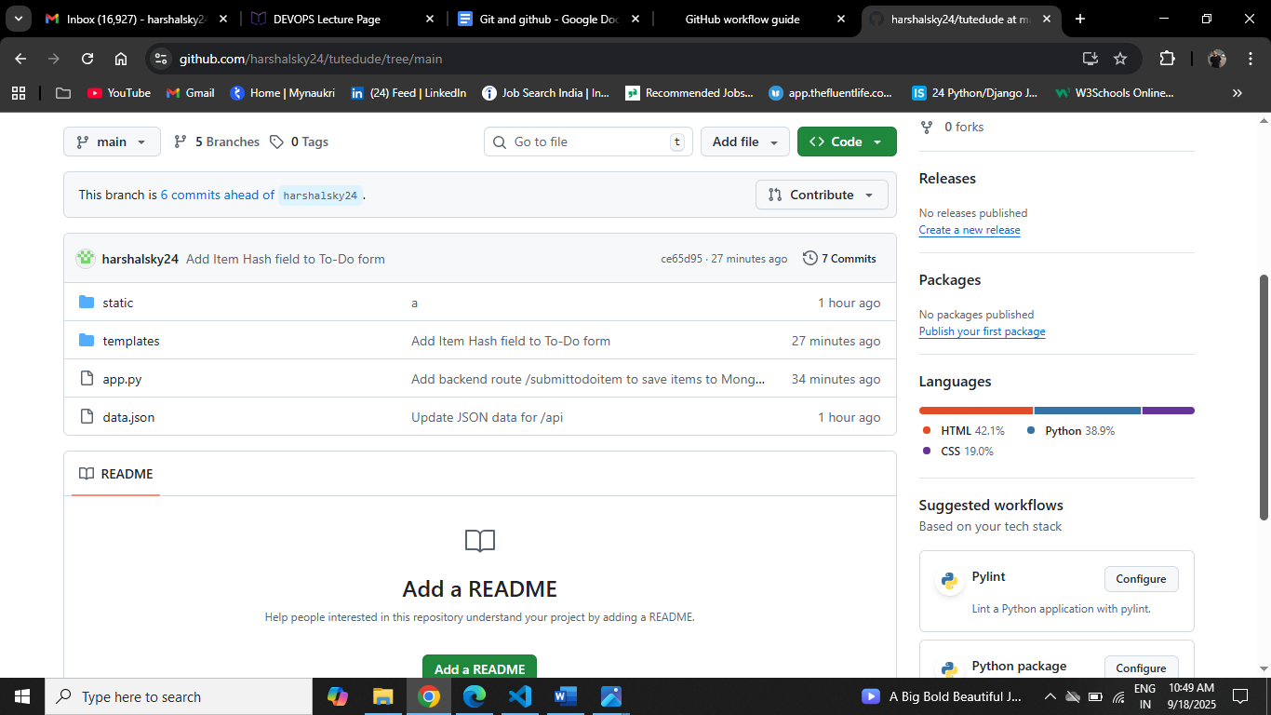

2. Create a new branch named <your_name>_new (e.g., Tutedude_new). Update the content of the JSON file used for the /api route in this branch. Merge the <your_name>_new branch into the main branch. If there are conflicts during the merge, resolve them by accepting the changes from the <your_name>_new branch. Add the resolved changes to the staging area, commit them, and push the updates to the remote repository.

# Create and switch to new branch
git checkout -b harshalsky24_new

# Edit data.json (update /api content)
git add data.json
git commit -m "Update JSON data for /api"
git push origin harshalsky24_new
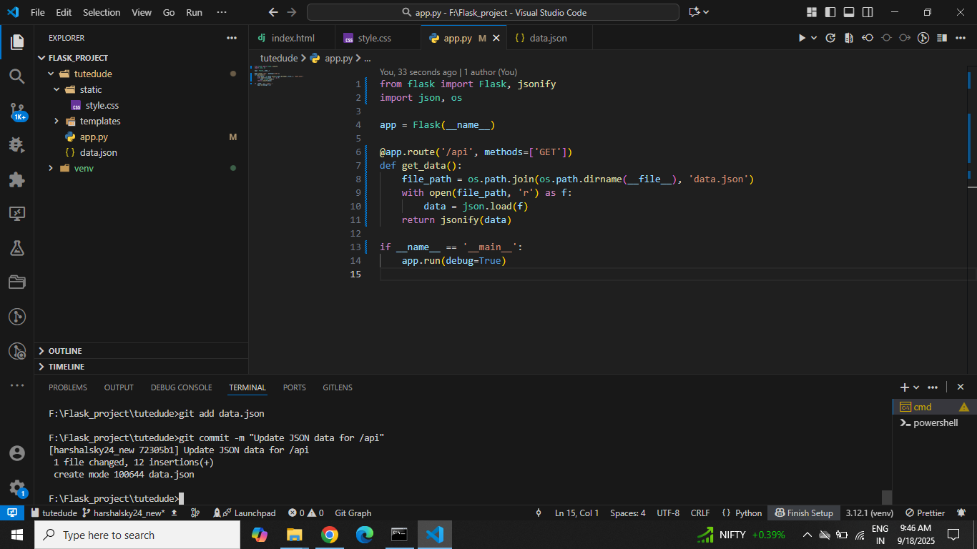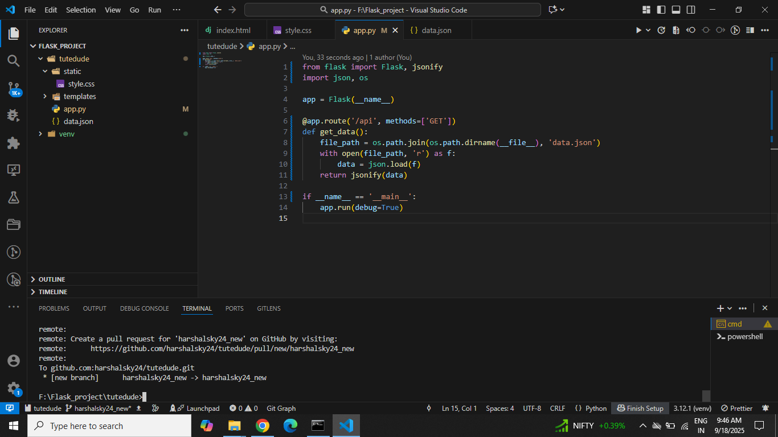

# Merge to main
git checkout main
git merge harshalsky24_new
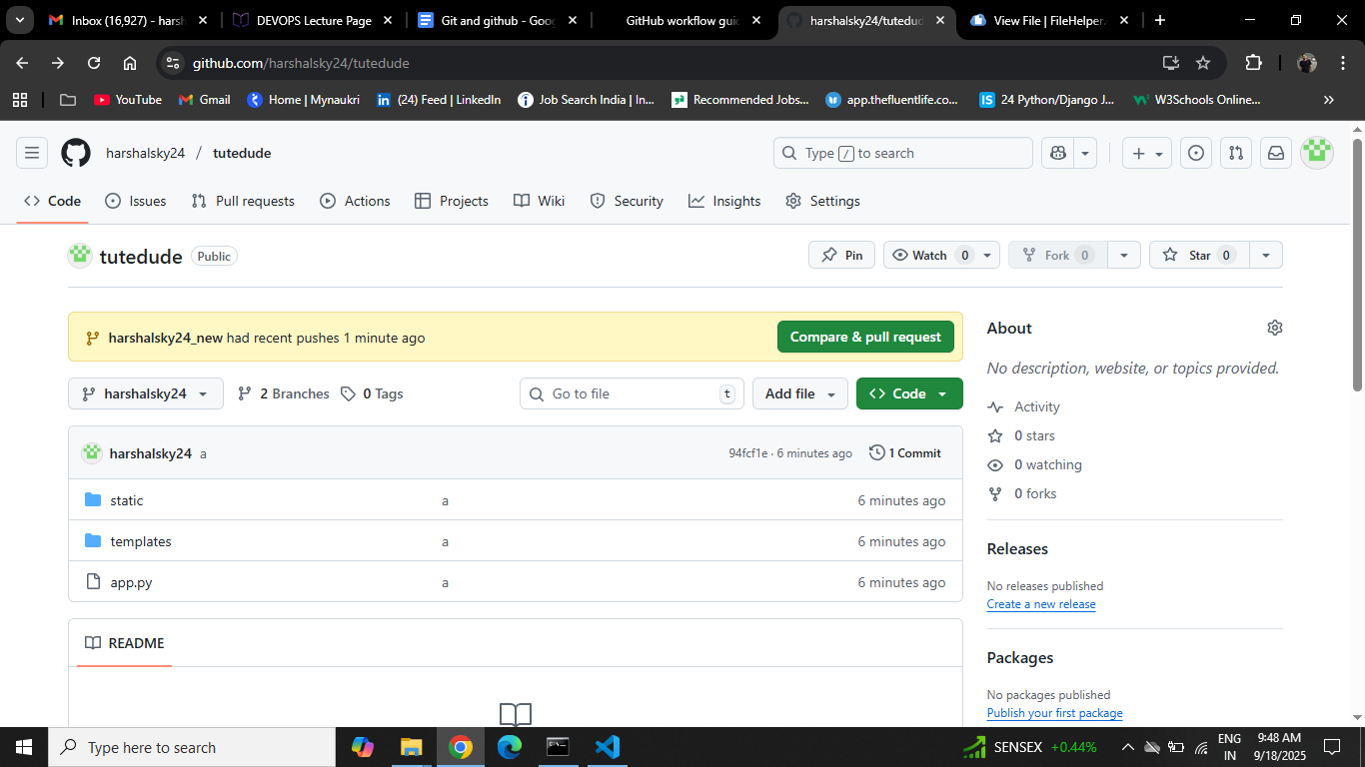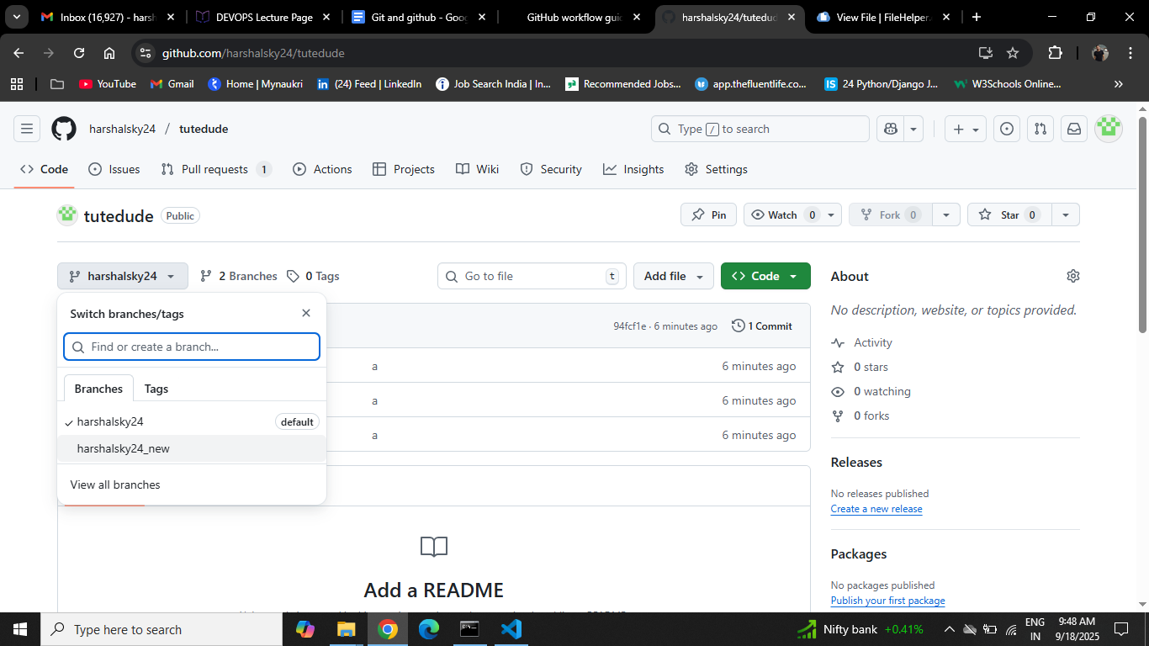

3. Branch Creation: Create two branches: master_1 and master_2 from the main branch. Feature Development in master_1: In the master_1 branch, create a To-Do Page in the frontend. The page should contain a form with the following fields: Item Name Item Description Backend API in master_2: In the master_2 branch, create a backend route named /submittodoitem. This route will: Accept itemName and itemDescription via a POST request. Store these details in a MongoDB database. Merging Changes: Merge the changes from both master_1 and master_2 into the main branch.

# Create feature branches
git checkout main
git branch master_1
git branch master_2
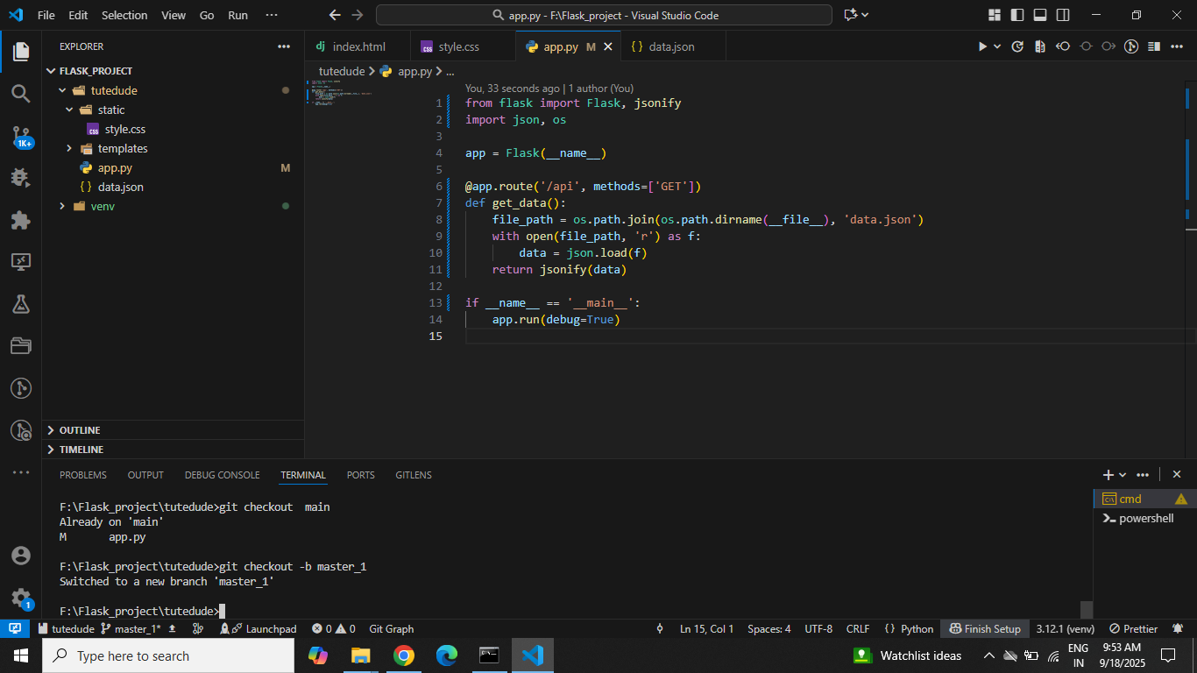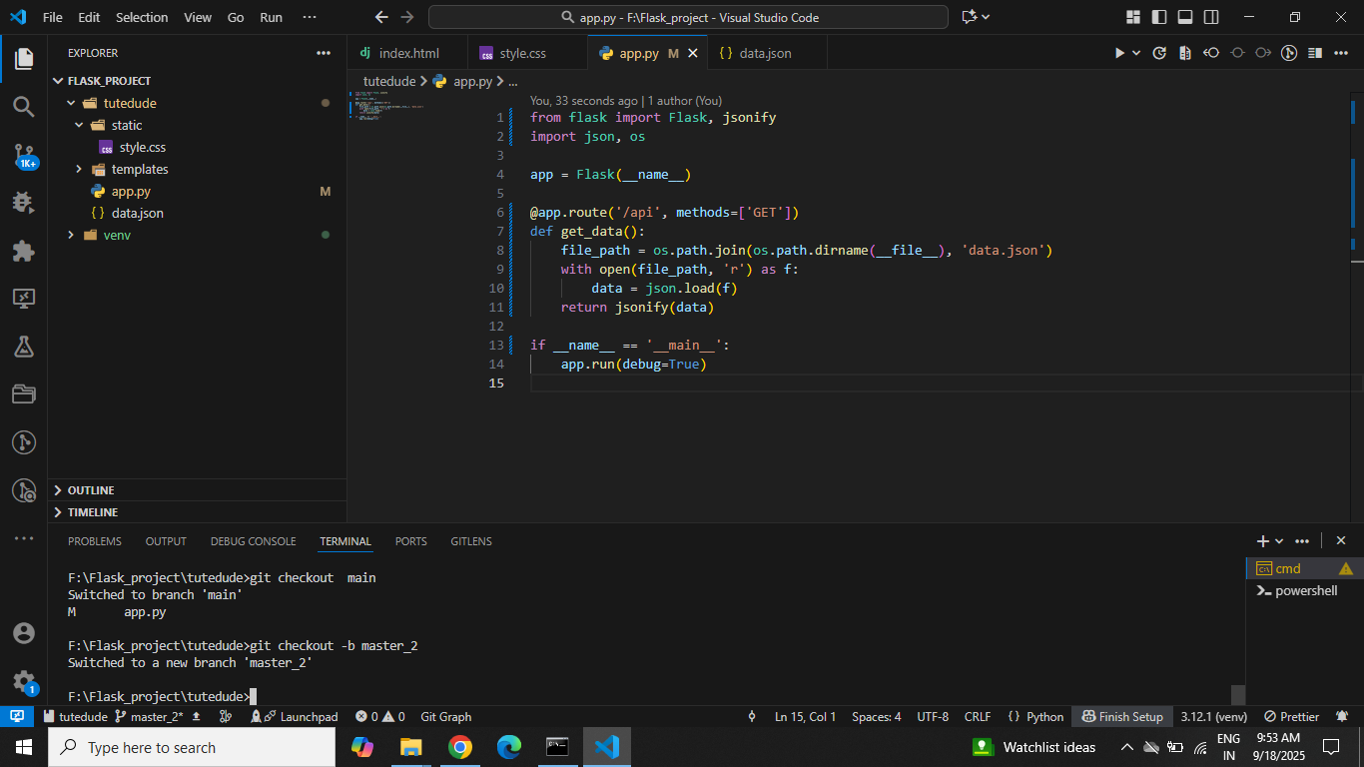
# --- Frontend in master_1 ---
git checkout master_1
# Create templates/todo.html with Item Name + Item Description fields.
git add templates/todo.html
git commit -m "Add To-Do Page with form (Item Name, Item Description)"
git push origin master_1
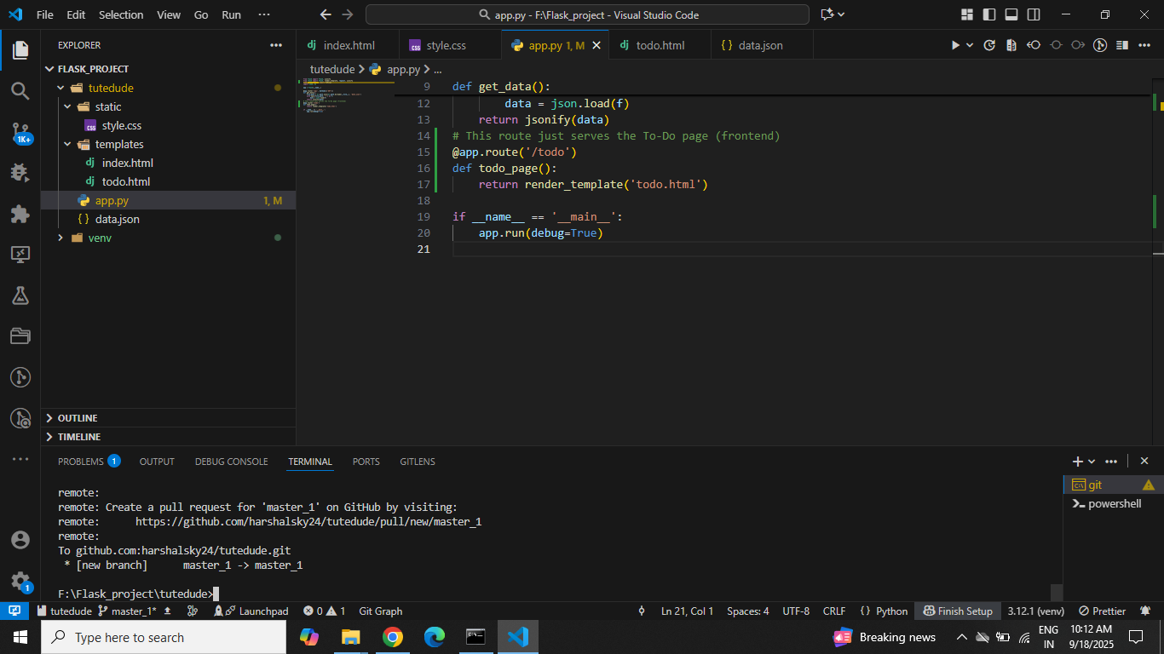
# --- Backend in master_2 ---
git checkout master_2
# Edit app.py: add /submittodoitem POST route saving to MongoDB.
git add app.py
git commit -m "Add backend /submittodoitem route storing data in MongoDB"
git push origin master_2
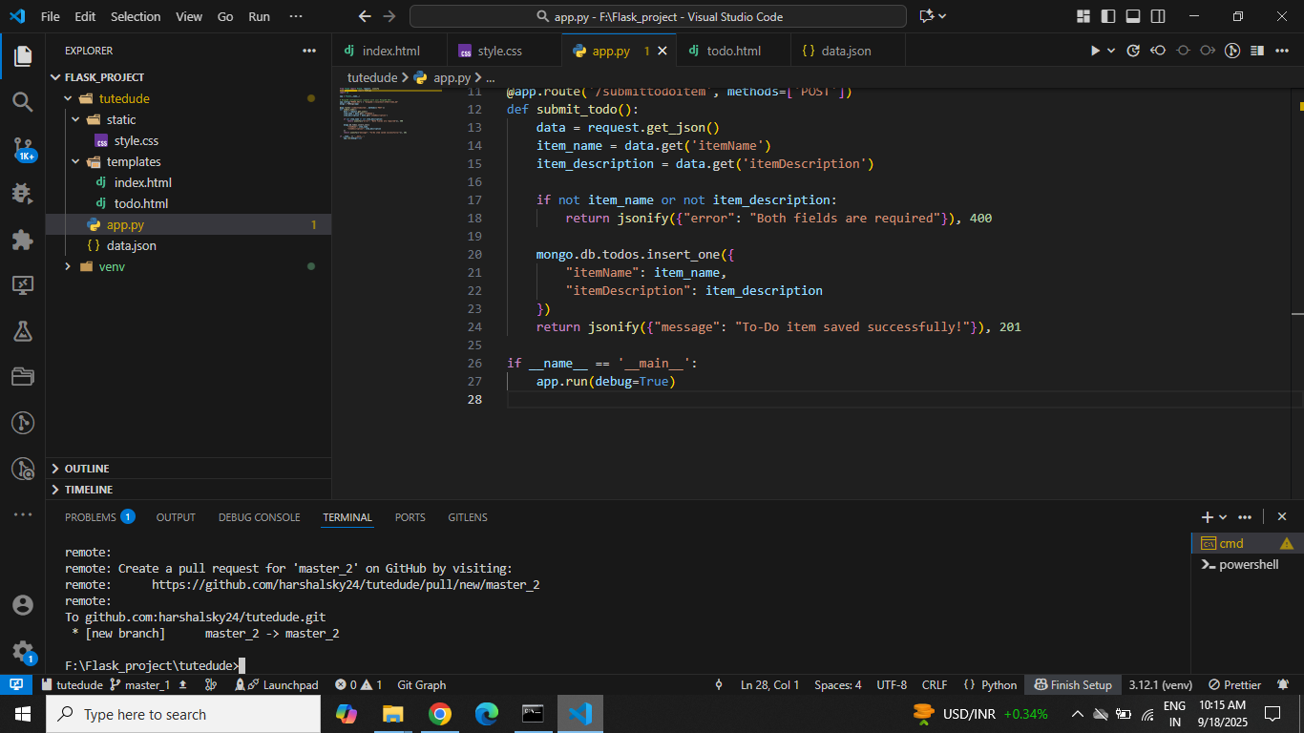

# --- Merge back ---
git checkout main
git merge master_1
git merge master_2
git push origin main
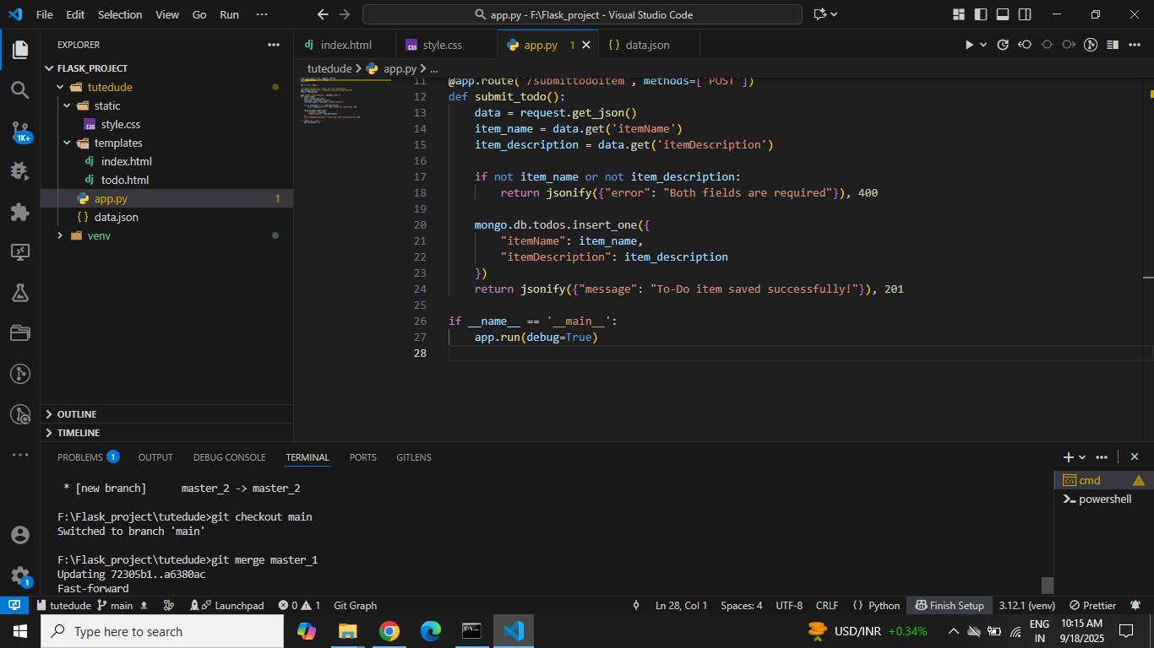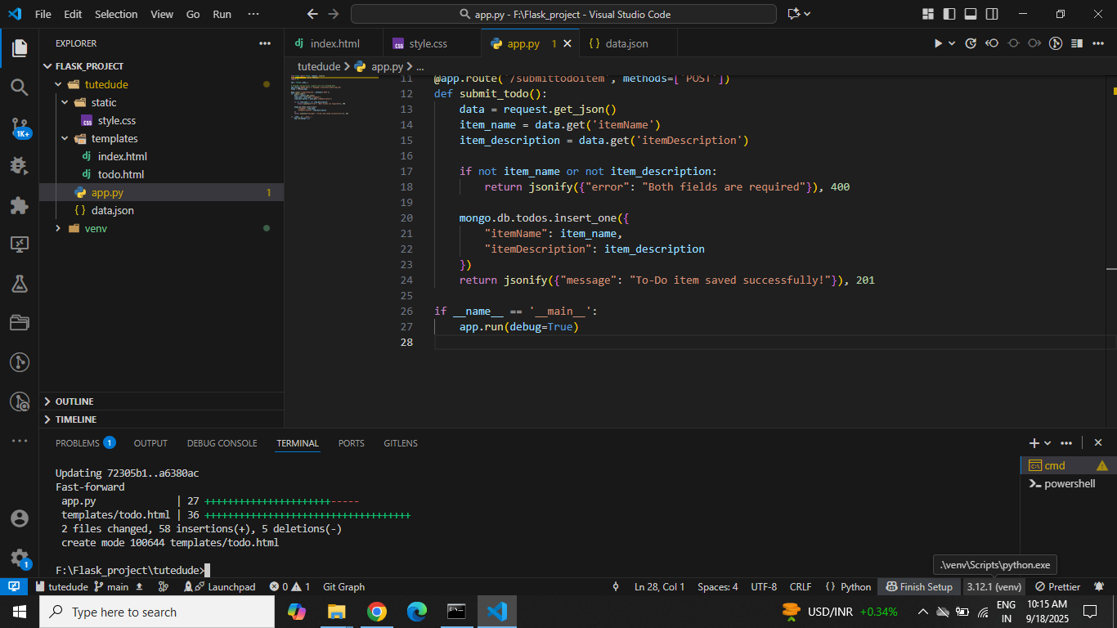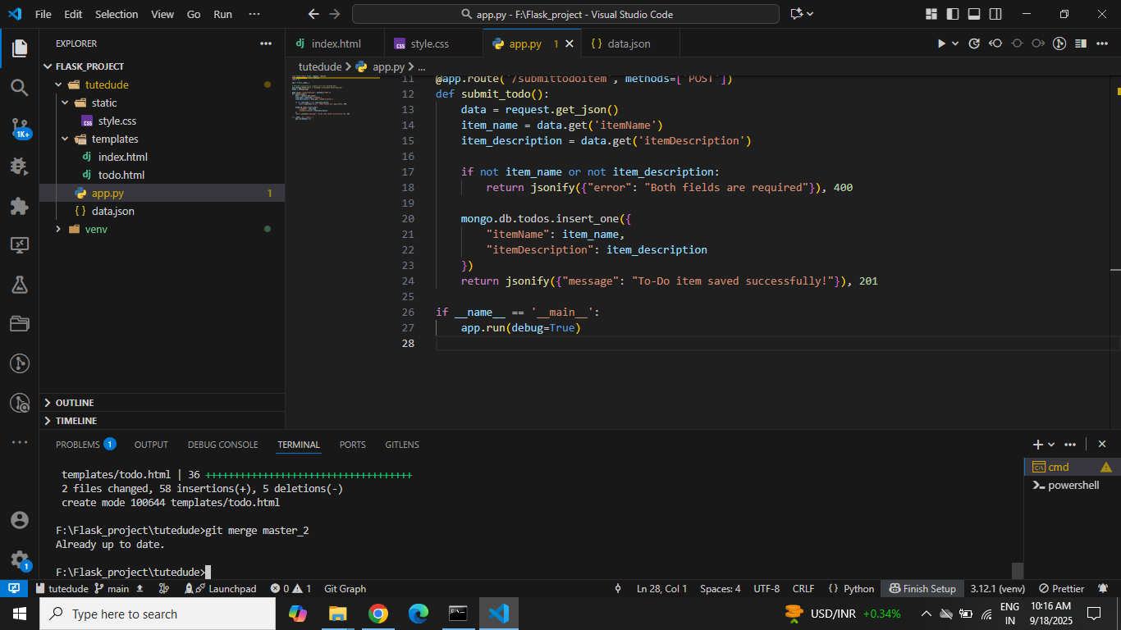
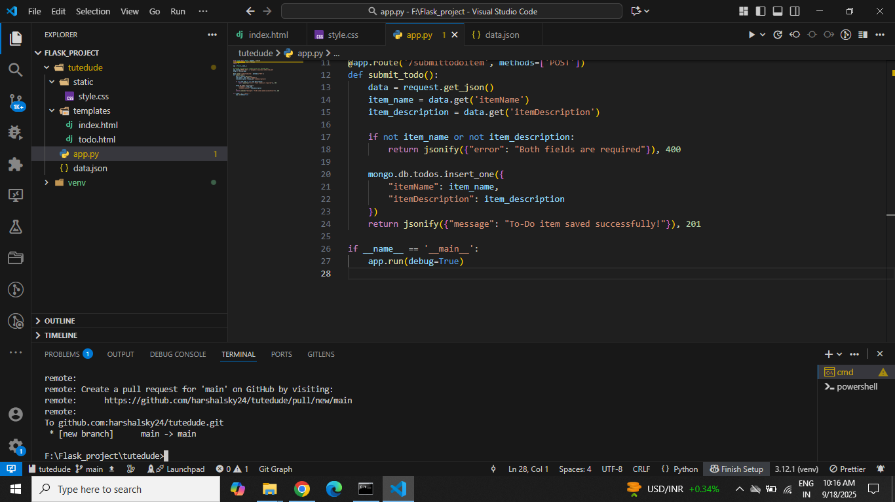

4. Enhancing the To-Do Form in master_1: In the master_1 branch, add the following fields to the To-Do form: Item ID Item UUID Item Hash Committing in Sequence: Add and commit each field separately in the following order: First commit: Add Item ID field. Second commit: Add Item UUID field. Third commit: Add Item Hash field. Merging to main: Merge the master_1 branch into the main branch. Git Reset and Commit Deletion: In the main branch, use Git Reset to roll back to the commit where only the Item ID field was added. Use git reset --soft to ensure changes remain staged. Re-commit this state to the main branch. Merge this updated state to the main branch. Rebasing Changes: Rebase the updated changes in the main branch to the master_1 branch. Clarification: During rebasing, preserve individual commits to maintain the commit history for each change (i.e., do not squash commits). Use git rebase main master_1 to integrate changes from the main branch back into the master_1 branch.

# Switch to master_1 for form enhancements
git checkout master_1

# --- Commit 1: Add Item ID ---
# Edit templates/todo.html → add Item ID field
git add templates/todo.html
git commit -m "Add Item ID field"
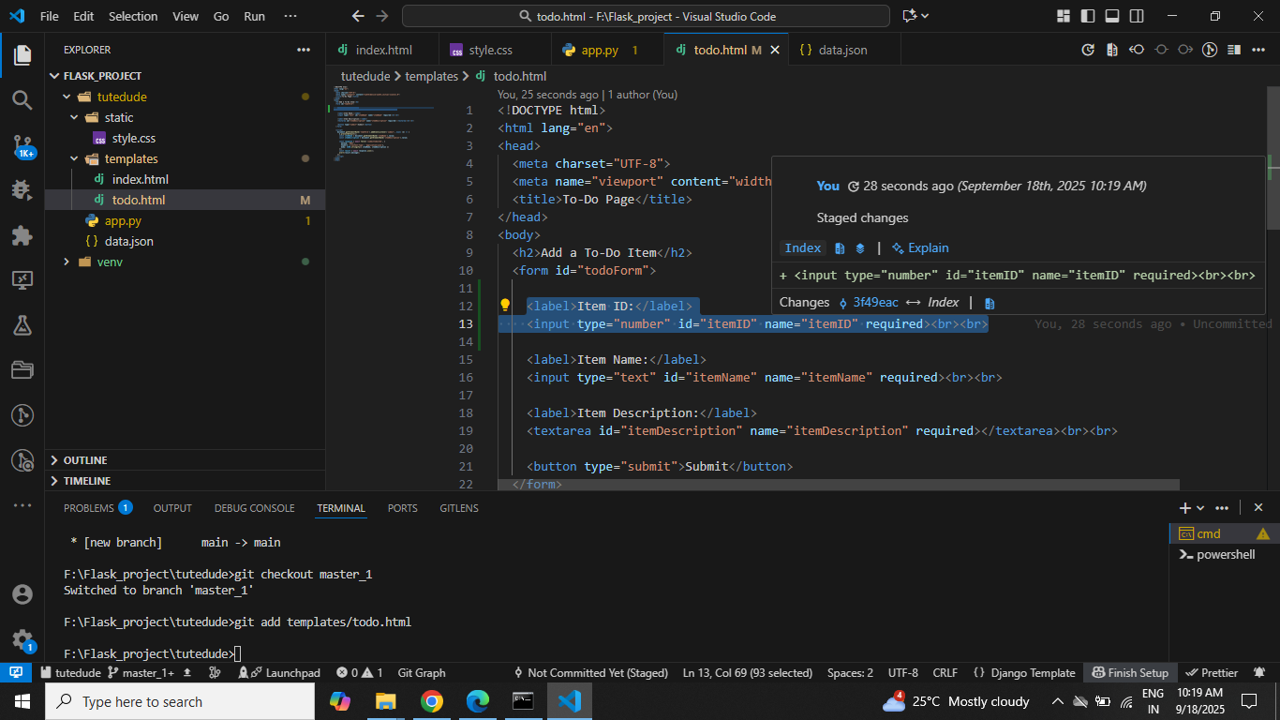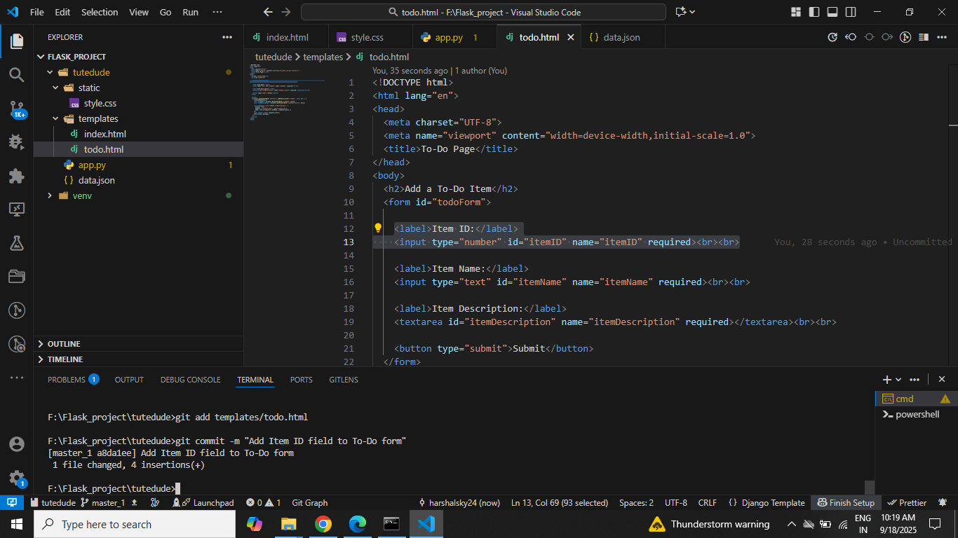
# --- Commit 2: Add Item UUID ---
# Edit again → add Item UUID field
git add templates/todo.html
git commit -m "Add Item UUID field"
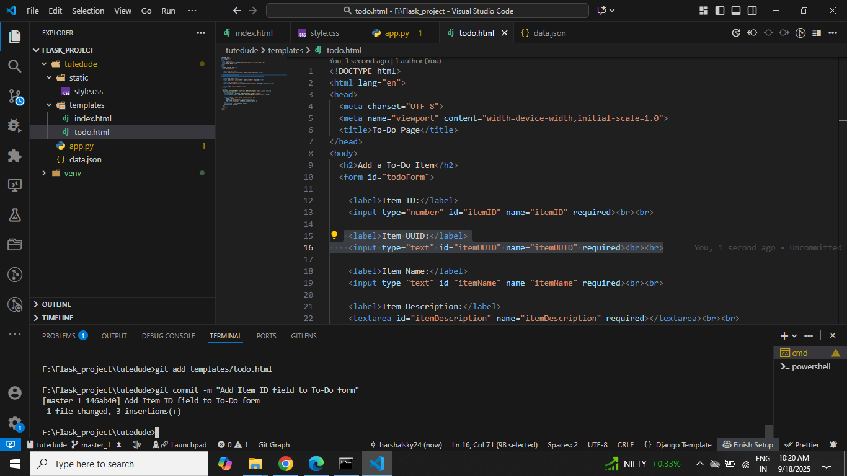

# --- Commit 3: Add Item Hash ---
# Edit again → add Item Hash field
git add templates/todo.html
git commit -m "Add Item Hash field"
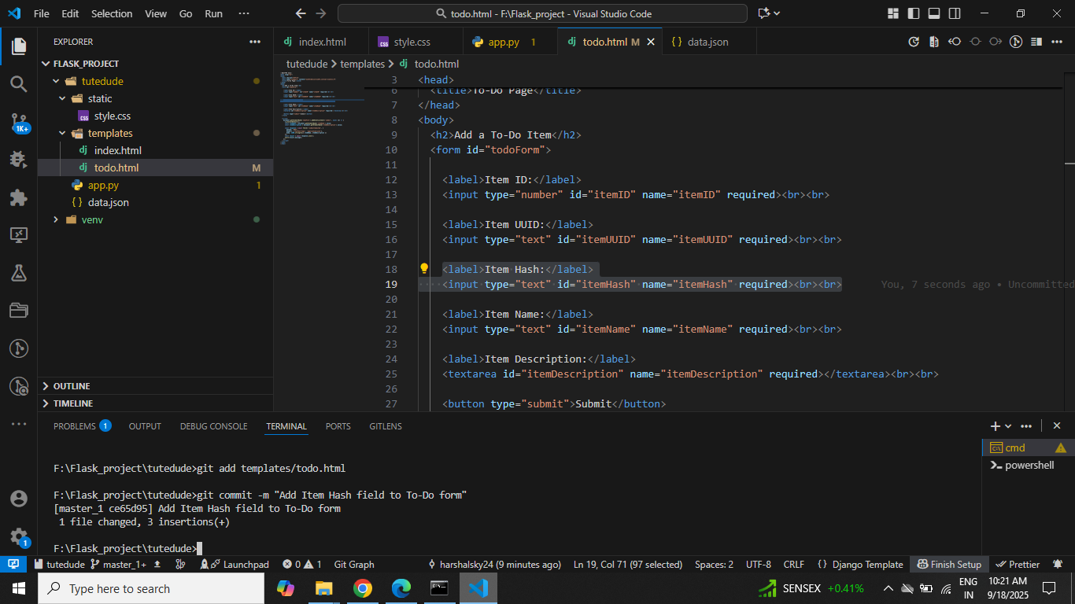
git push origin master_1
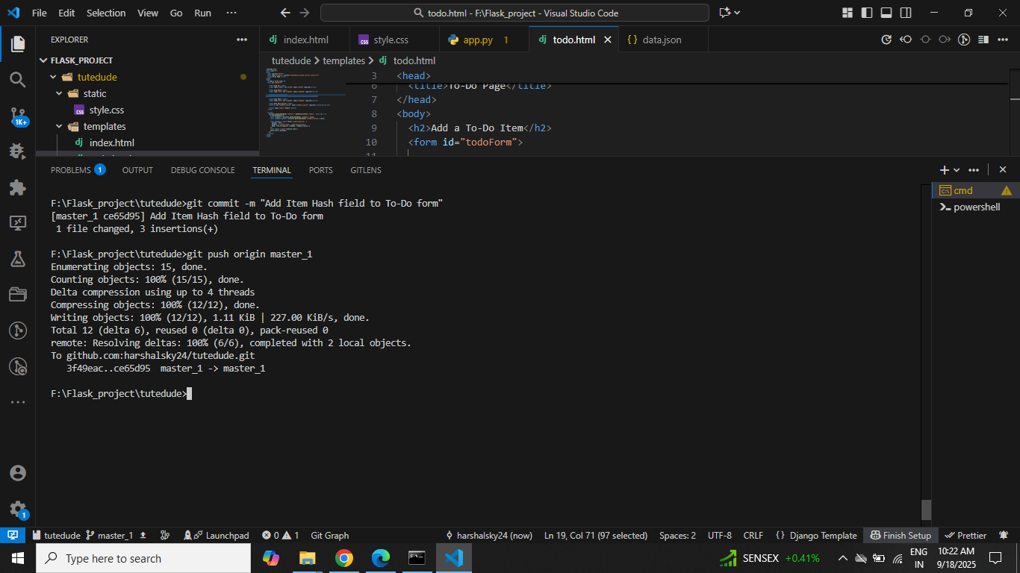
# Merge to main
git checkout main
git merge master_1
git push origin main
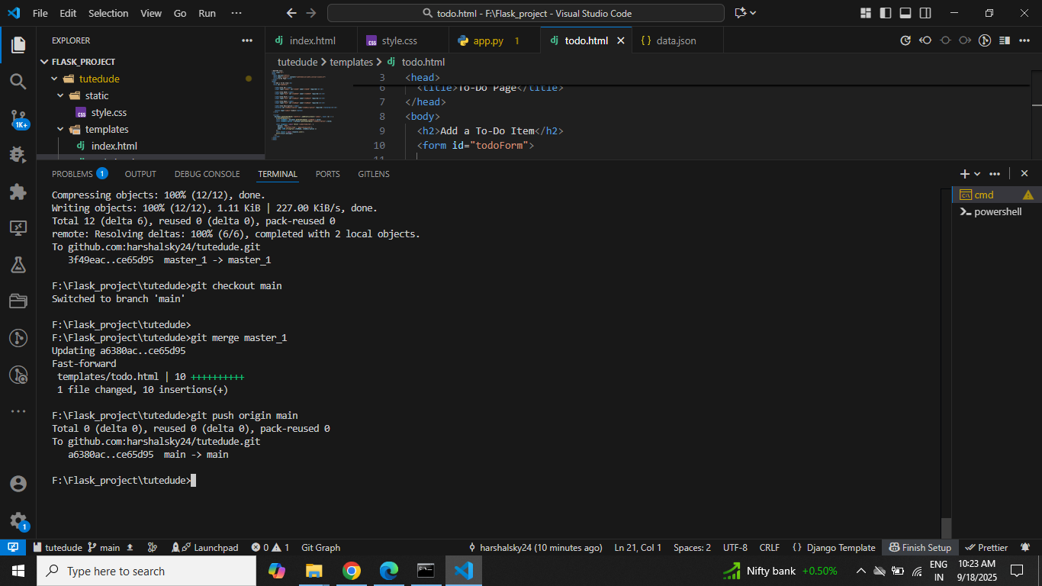
# --- Git Reset to rollback to Item ID only ---
git log --oneline # Find commit hash for "Add Item ID field"
git reset --soft <commit-hash> # <-- use hash without < >
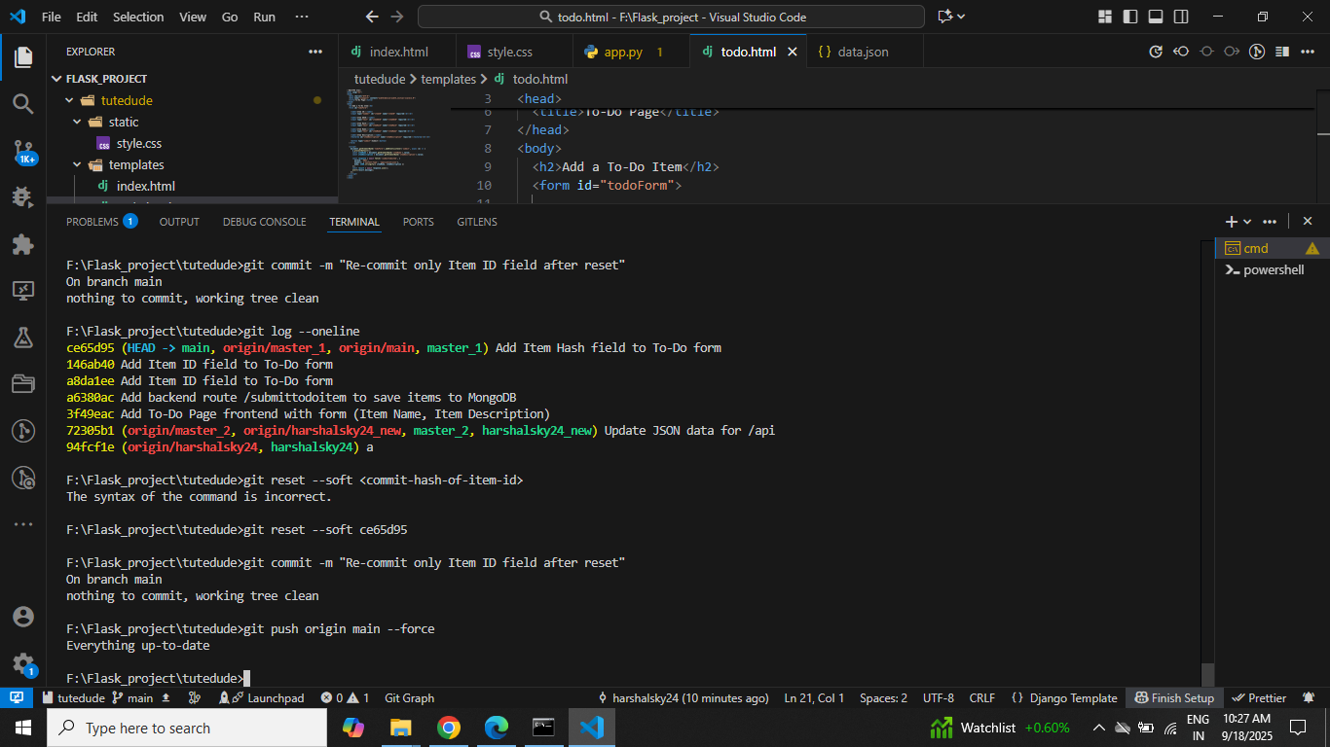
# Re-commit this state
git commit -m "Re-commit only Item ID field after reset"
git push origin main --force-with-lease

# --- Rebase master_1 onto main ---
git checkout master_1
git fetch origin
git rebase main # Preserve commits individually
